6/17/2024 WGHA BOD Agenda
7 pm @ Liz Fenster’s home

Agenda
Review and approve 4/15/24 WGHA BOD meeting minutes;
- Review ACC report;
  - Oxwood yard waste follow up
- Review Greenway report;
  - Sign Damage
  - Storm Damage - status
  - Electrical - status
- Review Social committee report;
  - Adult focused social requested - Greenway Crawl
  - July 4th plans
- Review Block Captain report;
  - Directory delivery
  - Openings on Colony Circle, Walnut Grove Condos
- Treasurer Report
- Newsletter
- Discuss other issues
  - Fertilizer + Weed Control Information from Keyman
  - Registry: https://datcp.wi.gov/Pages/Programs_Services/LandPestReg.aspx
- Set next meeting date: August TBD at 7pm

6/17/2024 WGHA BOD Minutes
7 pm via Zoom

Minutes
Present: Liz Fenster (President and Treasurer); Doug Hyant (Vice President); Phillip Kent (Secretary); Danielle Basirullah (Architectural Control Committee); Hayden McCann (Greenways Chair); Charlie Morgan (Social Co-Greenway Chair); Meghan Johnson & Chris Delamarter (At Large Members
Excused: Laurie Howard (Block Captain Chair)
  - The meeting was called to order at 7 p.m. The 4/15/24 WGHA BOD Meeting Minutes were unanimously approved.
  - The Architectural Control Committee report by Danielle was reviewed. Two applications have been approved and we have received 3 inquiries. The board emailed and hand delivered a letter to the homeowners at 30 Oxwood Circle requesting they remove a brush pile by the end of June which is in violation of our covenants. Danielle and Phillip will monitor this situation and report back to the board regarding the brush pile after 7/1/24. If the pile is not removed the homeowners will be contacted to ask if they need any assistance in this matter.
  - The Greenways Report by Hayden was reviewed. Hayden reviewed the damage to the Greenways due to recent storms. For specifics, please see the report accompanying these minutes. In brief, some trees sustained significant damage necessitating their removal. Beeline will replace three light posts as their schedule permits. The remaining light posts have been painted. A general discussion was held regarding the repair and or replacement of several signs ensued. A general discussion was held regarding the importance of preventative maintenance and the committee being good stewards of WGHA funds. Priorities at this time include tree pruning and dealing with insect control. Greenway volunteers prepared and installed a rain/pollinator garden. Charlie noted Hayden did a marvelous job coordinating this project.
  - The Social Committee report by Charlie was reviewed. We discussed the nature and purpose of the three upcoming events: Make Music Madison on 6/21; the Independence Day Celebration (rain date 7/6); and the Fall Crawl on 9/21. Charlie has met with Paige and others to help plan these events. We discussed the possibility of getting high school students and other folk to help volunteer for these events. Liz will be sending out an email to the WGHA to let them know of upcoming social events and work with Mehgan to incorporate a Sign Up Genius link to facilitate the recruitment of volunteers. It was noted that relatively few WGHA funds are spent on social events, and we need to continue these and other events to continue to reach out to our neighbors.
  - The Block Cation report was reviewed. The new printed Directory will soon be delivered to all WGHA homes. Liz will follow up with various Block Captains to ensure this is done.
  - The Treasurer report by Liz was reviewed. At this time there are 23 outstanding dues and a reminder will be sent to the respective homeowners to urge them to pay their dues. Our Directory has been paid for. Liz purchased a couple of CDs at Summit Credit Union to help grow out money. We had a general discussion of budgeting priorities.
  - Meghan reported she will be composing a WGHA Newsletter soon. A general discussion was held regarding its potential content.
  - Hayden provided a report on Fertilizer and Weed Control as requested at our last meeting and it is enclosed with these minutes. The question was raised if there are viable organic alternatives. Mehgan volunteered to investigate possible options and report her findings at the next BOD meeting.
  - Our next WGHA BOD meeting will be held on 8/19/24 at 7pm.
  - The meeting adjourned at 8:34 pm.

Phillip L. Kent, Secretary

WGHA ACC Committee Report
Board Meeting 06/17/2024

Submissions
- 2 applications received
  - 7405 Farmington Way- Application was approved for backyard landscaping project which includes plants, privacy screen, and flagstone patio
  - 21 Southwick Cir- Application was approved for roof-top solar panel project

Inquires
- 3 inquiries received
  - 7209 Colony Dr- homeowner is planning to submit application for privacy screen; original inquiry was in April 2023
  - 7014 Farmington Way- inquiry regarding approval for change to front yard planting beds; application not expected since there are not ACC guidelines for these types of changes within homeowner’s yard
  - 18 Southwick Cir- Inquiry regarding replacement of existing rock wall on side yard; application not expected since there will be no change to height, length or grade surrounding existing wall

Covenant Violation
- Board sent letter to homeowners at 30 Oxwood Circle to request removal of brush pile in backyard

Submitted by: Danielle Bashirullah, ACC Chair

Greenways Report
Board Meeting 06/17/2024

The Greenways Committee has completed one of three planned meetings for the season. The next is Tuesday July 9 at 7pm in Walnut Grove Park followed by a Greenways Volunteer Workday Saturday July 13th at 9 am. The meeting place will be near the Stonecrest walkway.

Painting of the remaining light posts was completed in May. #12 was omitted as it is due to be replaced.

Damaging storm # 1 necessitated removal of a large Oak on Greenhaven Circle.
A large fractured Box Elder branch at the rear of Southwick Circle was removed by an owner.

Damaging storm # 2 necessitated removal of a Maple on Stonecrest walkway.
A large fractured Oak branch was removed from Springwood Circle walkway.
A fractured Cottonwood branch was removed from Harwood Circle North walkway.
The Walnut Grove sign at the intersection of Old Sauk & Westfield Rd and a sign in Greenway D near the Foxboro walkway were damaged. An estimate for repair has been requested.

Outstanding storm damage included removal of a hanging Oak branch in Greenway D near light post # 25 and pruning the fractured area of a Box Elder in Greenway A whose branch was removed.

Greenway volunteers prepared and installed a Rain/Pollinator Garden consisting of 80 native perennials adjacent to the Oxwood walkway. There are now 3 native plant installations in Greenway C.

A watering crew for these areas and watering bag support for the Sugar Maple planted in Greenway B in fall 2023 is in place.

Beeline Electric will replace 3 light posts when their schedule permits.

Arbor Systems bid for Emerald Ash treatment and pruning on Greenways A, B, C is pending.

Questions may be directed to greenways@walnutgrovemadison.org.
Submitted by Hayden McCann, Greenways Co-Chair

Fertilizer & Weed Control Follow Up
Provided by Keyman Fertilization & Weed Control

This year, our first treatment was 5/15/24. We prepaid in December for all three treatments this year. Based on history, it looks like our second treatment will be late June and third will be in September.

Is the weed control applied everywhere, or spot treated?
The first application is typically broadcast the remaining applications are spot sprayed as needed.

Are these "herbicides"? (want to ensure we use the right terminology)
Weed control is a Herbicide.

Are there 3 treatments per season?
We offer 3,4 and 5 treatment programs. Your association “paths” are on a 3 treatment program.

How long should residents remain off the treated areas? Is this due to the fertilizer, weed control chemicals, or both?
The label states until the product has dried. This can range from 10 minutes to a couple hours. There is no re-entry restrictions for fertilizer only herbicide.

What happens if you fertilize, but don't use weed control products? (aka do the weeds just go crazy?)
Yes, you get happy, vibrant weeds.

See Appendix for Product documents.
Submitted by Liz Fenster
Social Report
Board Meeting 06/17/2024

Make Music Madison. On Friday, June 21, beginning at 6:00 pm, Julie and Mark Webber will once again host music performances in their front yard at 6 Colony Circle as part of the city-wide Make Music Madison celebration. Refreshments will be available! Signs promoting the event are up, and a reminder email should be sent to households a few days before the event. Attendees should plan to bring their own lawn chairs, although some seating will be available.
Independence Day Celebration. The WGHA Independence Day celebration will be on Thursday, July 4th at 10:00 am at Walnut Grove Park. The annual celebration will include a bike parade, a water balloon toss, a trivia quiz, and several new activities, including sidewalk chalk stenciling, a bracelet crafting table, and a pinata. Refreshments will include Freezer Pops, juice boxes, ice water, and candy remaining from the Easter egg hunt.
Volunteers are needed to make this event a success! Jobs will include setting up and decorating tables, assisting with the activities and refreshments, passing out name tags and trivia quizzes, and clean up. I'd ask that all Board members who are available on that day commit to volunteering for the event, and seeking other volunteers. This year, we'd like to make a greater effort in recruiting older kids to staff some of the activities.
Fall Crawl. Planning is underway for a social event this fall, a "Fall Crawl." We are planning the event for Saturday, Sept 21 (with a rain date Sunday, September 22). Paige Hawkins and I discussed some ideas for this year's event, including offering beverages (beer, wine, soft drinks) and picnic-like food (brats, hotdogs, potato salad, vegetable trays). We'll need to recruit volunteers, including Board members, and plan to meet in early August to finalize preparations for this event.
Submitted June 14, 2024
Charlie Morgan, WGHA Board Social Chair

Block Captain Report
Board Meeting 06/17/2024
Submitted by Laurie Howard

Directories
Friday, May 31 - Directories picked up at printers
Thursday, June 6 - Open house from 6:00 - 8:00pm for all block captains to stop and pick up their directories.
Saturday, June 8 - All directories dropped at block captain homes who did not show on Thursday night.

Danielle graciously took the Walnut Grove Condo directories while we are waiting for a new block captain. We are hoping Jess and Randy will step up and assist.

Leann Johnson on Colony Circle did pick up the directories but is still looking to have a new owner assist. In reviewing my last minutes, Charlie was either going to e-introduce me to the Andersons or ask them individually. I’ll follow up with that.

During the directory pick up I meet Jenny Peabody (Whitacre). She is very excited to help plan the greenway crawl or help with other social activities. She is a past event planner and looking to become more involved.

Lastly, I sent a reminder email to all block captains to have the directories to all neighbors by the end of this week. Also sent a link for the recycling oversight the City of Madison will begin conducting. Carding trash cans that are not compliant.
PS - LOVE the advertiser logo signature block!

Treasurer’s Report
05-31-24 Snapshot Submitted by Liz Fenster
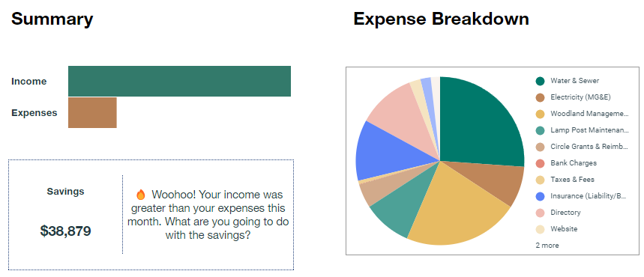
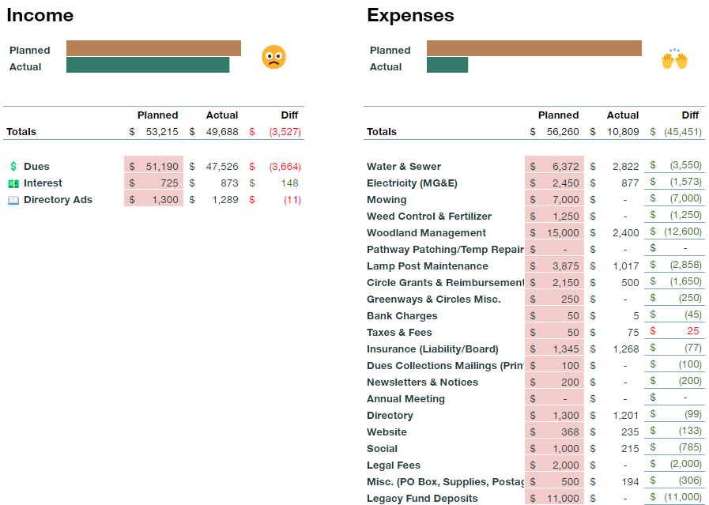

KEY NOTES:
- Taxes & Fees include 2023 reimbursement to Kim Grimmer for DFI filing (2023 was under budget)
- Website includes a $140 recovery fee

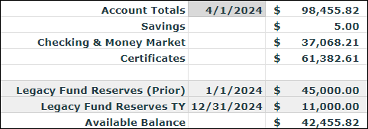

Dues Recap
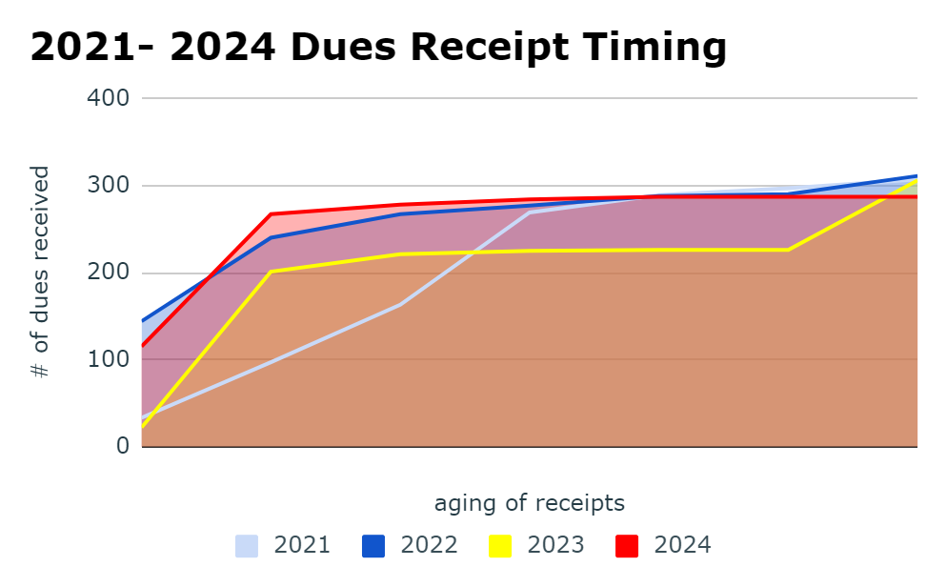

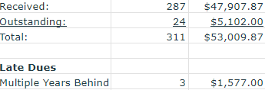

APPENDIX
